**Name:** Phani Kumar

**Batch:** June 01 2022

**Tutor:** Phani Kumar

**Project Name:** Infra setup through Terraform.

**Project:**

1. Created an EC2 instance and connected
2. Installed Terraform in instance from website releases.hashicorp.com/terraform/ by using command wget

<https://releases.hashicorp.com/terraform/1.1.3/terraform_1.1.3_linux_amd64.zip/>

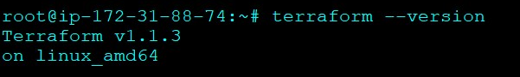

1. Moved terraform to bin by using command mv /usr/local/bin
2. Created user in IAM and saved credentials (Access key id & Secret access key)
3. Install aws cli by using command ( apt install awscli )
4. Then used aws configure command and entered Access key and Secret key which i have created in IAM
5. Created Terraform directory by using ( mkdir terraform )
6. Moved to terraform directory ( cd terraform/ )
7. Created main.tf file by using touch main.tf

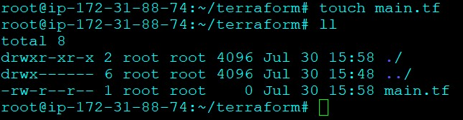

10 . wrote the terraform program on the main.tf file

11. Terraform Program to Create ( 1 VPC, 1RDS, 2EC2 INSTANCES (NAME : ONE & TWO), 3 S3 BUCKETS AND 4 IAM USERS (USER1, USER2, USER3 AND USER4):

provider "aws" {

region = "us-east-1"

}

resource "aws_vpc" "phani_vpc" {

cidr_block = "10.0.0.0/16"

tags = {

Name = "terraform_vpc"

}

}

resource "aws_db_instance" "phani_db" {

allocated_storage = 20

identifier = "terraformdb"

storage_type = "gp2"

engine = "mysql"

engine_version = "8.0.28"

instance_class = "db.m4.large"

db_name = "terraformdb"

username = "phani"

password = "Password"

apply_immediately = true

skip_final_snapshot = true

}

resource "aws_instance" "phani_ec2" {

ami = "ami-0cff7528ff583bf9a"

instance_type = "t2.micro"

for_each = toset(["one", "two"])

tags = {

Name = "${each.key}"

}

}

resource "aws_s3_bucket" "phani_s3_bucket" {

count = length(var.s3_bucket_names)

bucket = var.s3_bucket_names[count.index]

}

1. Ran terraform plan to check the program.
2. Successfully passed the program without error.Ran terraform apply command to execute the program and create the infrastructure
3. Successfully created ( 1 VPC, 1RDS, 2 EC2 INSTANCES (NAME : ONE & TWO), 3 S3 BUCKETS AND 4 IAM USERS (USER1, USER2, USER3 AND USER4):

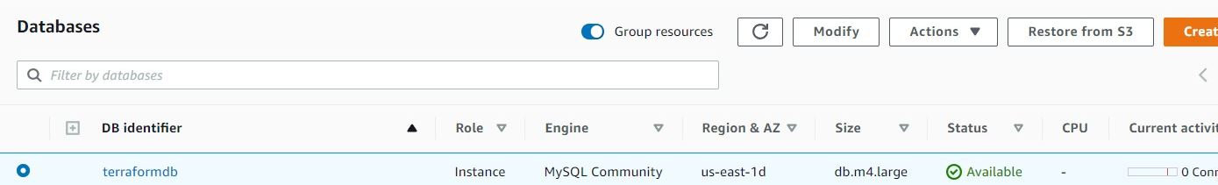

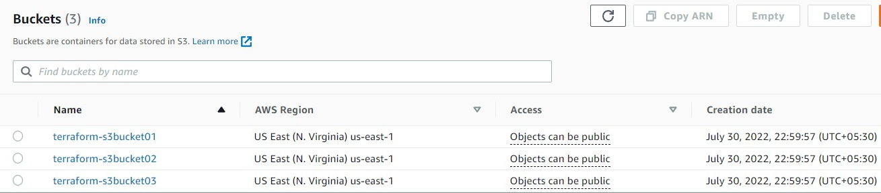





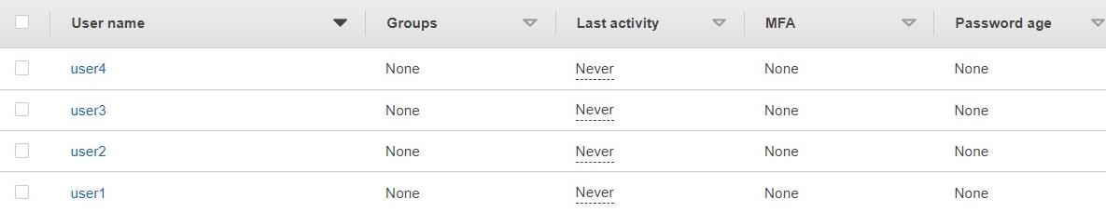

1. Deleted the infrastructure by running the terraform destroy command.